**KCAA Veteran’s Cross Country Championships**

**Additional online entry instructions – Rev 2021**

The online entry forms have been revised following requests for a single entry form with multiple age group selections. A **maximum of 32** online entries can be made with each entry or uploaded from the csv file created as per the instructions below.

Save the csv (comma-separated values) VetsTemplate file, the excel Entry Forms file into a convenient folder together with the Past Entries file if you have received it.

You are advised to read the Championship Prospectus and Instructions and complete a copy of your entry in the excel Entry Forms before preparing the csv upload files described below. For convenience it might be easier to save the Previous Entries file as your new entry form and update and modify accordingly. All athlete entries **must** include input in the EA Number, Dob and Qual columns. There must be no blank lines of data. This would probably best be achieved by sorting the entry by FirstName, LastName and Age Group Entered. You can copy data into the form from other excel or word documents but are advised to use the Copy and Paste Special – Format or Match Destination Formatting option so that the format of the entry form is not corrupted.

I welcome submission of any missing details, corrections, changes and updates of places of birth and residential qualifications. For new athletes born within the KCAA qualification area (B) details of where in Kent or the London Borough they were born or first went to live immediately after birth should be submitted. Kent has frequently been recorded as a non-specific place of birth for those born in the KCAA qualification area but ask for more specific information, if available.

The following instructions are a guide how to create the csv entry file and subsequently how to upload it using the online entry forms.

Open the VetsTemplate file from excel after selecting the folder where it has been saved using the All Files (“*”) option.

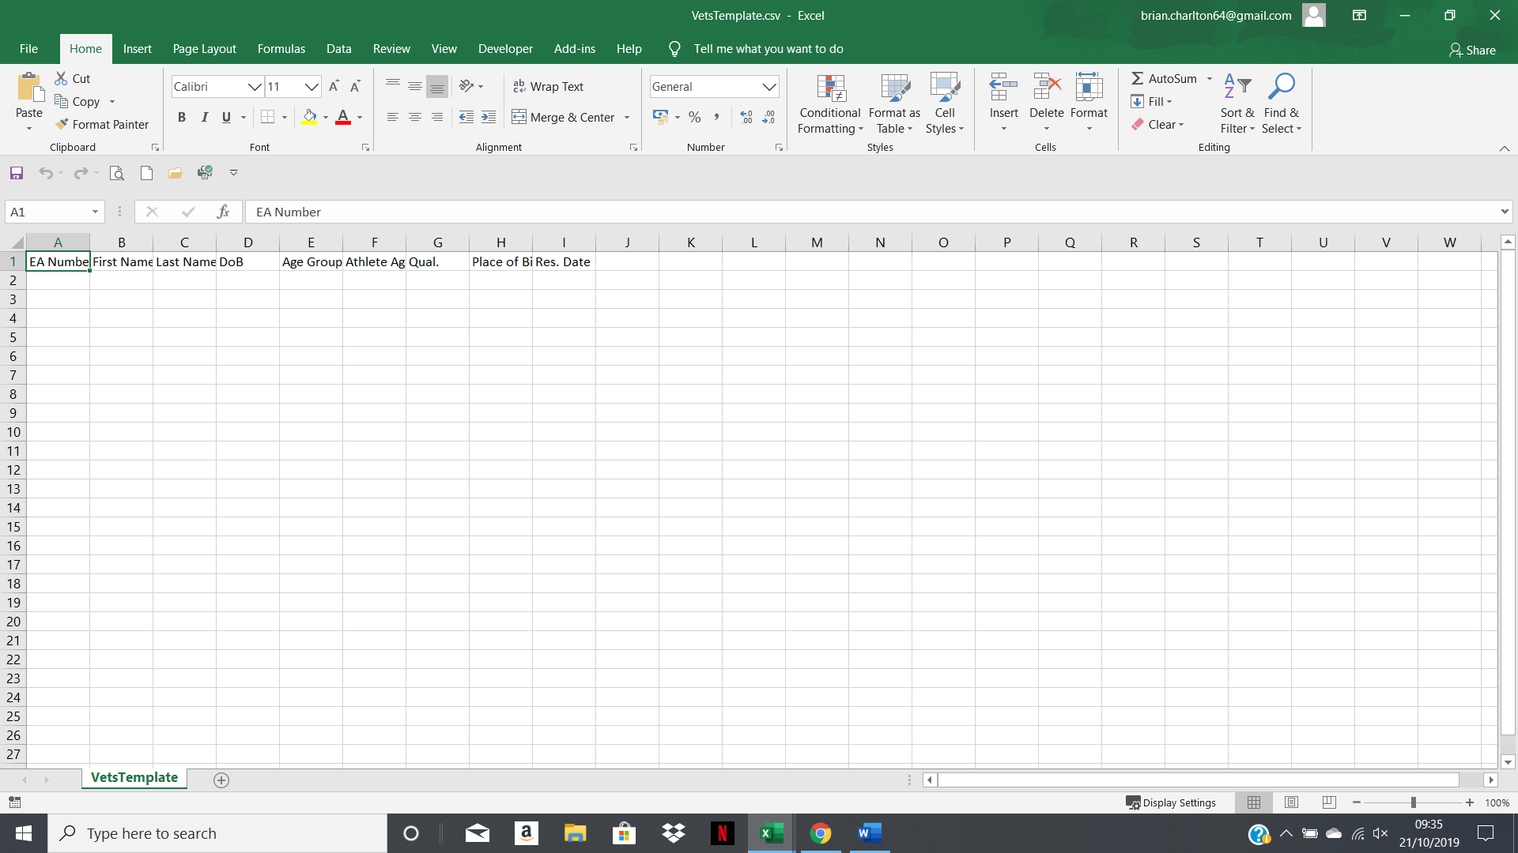

For simplicity the following instructions will assume that you received a copy of the past entry details or have already prepared the excel Entry Form.

I attach an extract from my sample fictitious Newnham Trotters Entry Form showing the previous year’s entry details.

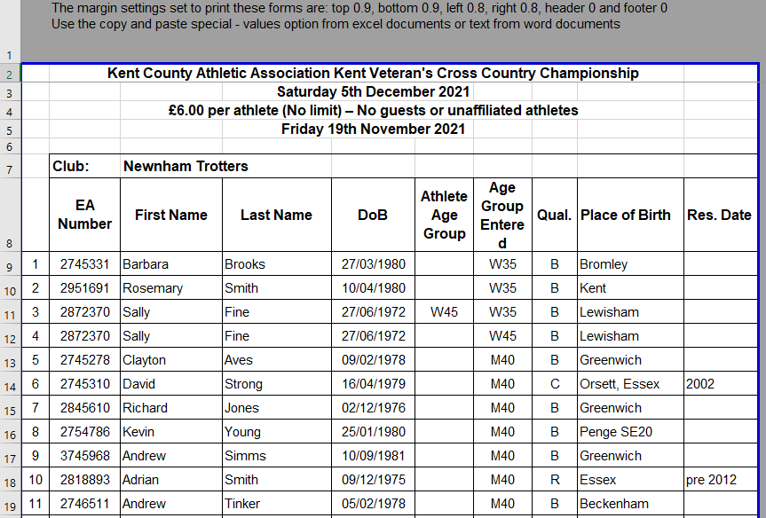

You should particularly note the 2 entries for Sally Fine, one as a W35 including an entry in the Athlete Age Group column flagging her entry in a younger age category and the other as a W45.

Copy the entry data ie cells B2 – H19

Select the VetsTemplate.csv file and paste into cell A2.

NewhamTotters (Clubname) in csv format

You **must not** save using the Macintosh .csv option as you will not be successful in uploading your entry.

The following warning message will be shown. Select yes

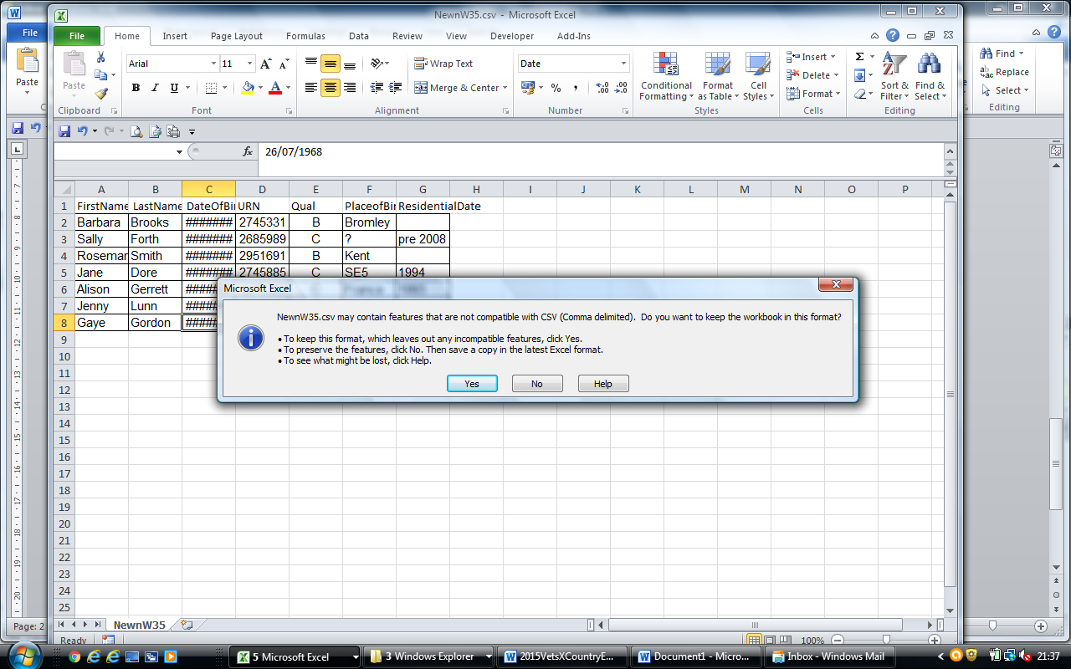

As this has been saved as a csv file most formatting will have disappeared in the saved file but for the date of birth Date format of dd/mm/yyyy which must not be changed.

Additional entries, amendments or correction can be made to this file but I repeat that It is essential that there is an entry in the EA Number, dob and Qual columns for all entries,

Repeat the same process as above to create the other age group entry csv file,

**How to complete an online entry**

Select the <http://www.kcaa.org.uk> website

Select the Cross Country tab and scroll down the page to find the Vets Cross Country Championship entry information. That will include a hyperlink to the online entry form.

Select the **Choose File button** and then select the csv file from the folder where it was saved.

Select the **Upload Athletes** button and the Athletes to Register table below will be populated. Some validation will made at this time to check that the input data is correct.

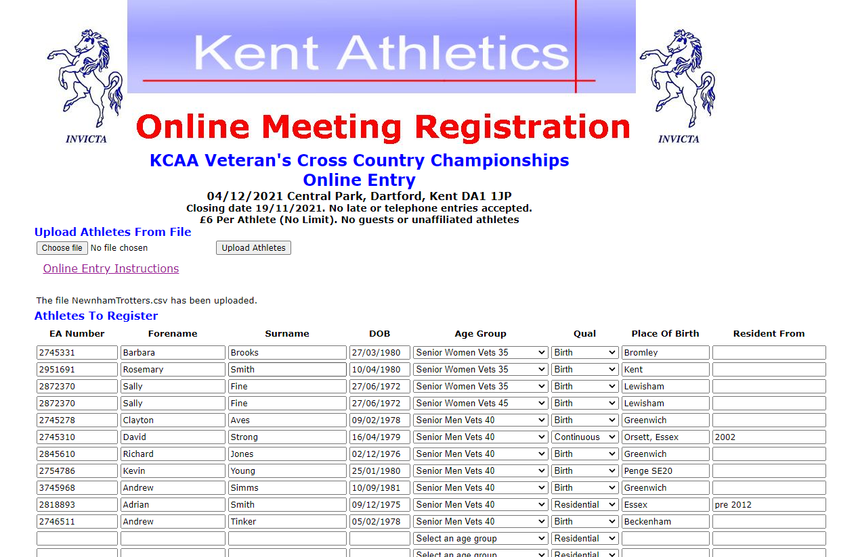

If you receive the successful file uploaded message and the Athletes to Register table is empty then you have not saved the upload file using the correct cvs option.

You can again add additional athlete names and details or correct the information which has been entered.

Alternatively if you don’t have the entry form details prepared and don’t wish to create the csv file you can individually enter the athlete details. You must enter the DOB in dd/mm/yyyy format, make an entry in the EA Number column and select the appropriate Birth, Continuous or Residential Qual and enter Place of Birth and Resident From as appropriate.

Scroll to the bottom of the form to complete the **Team Managers Information**

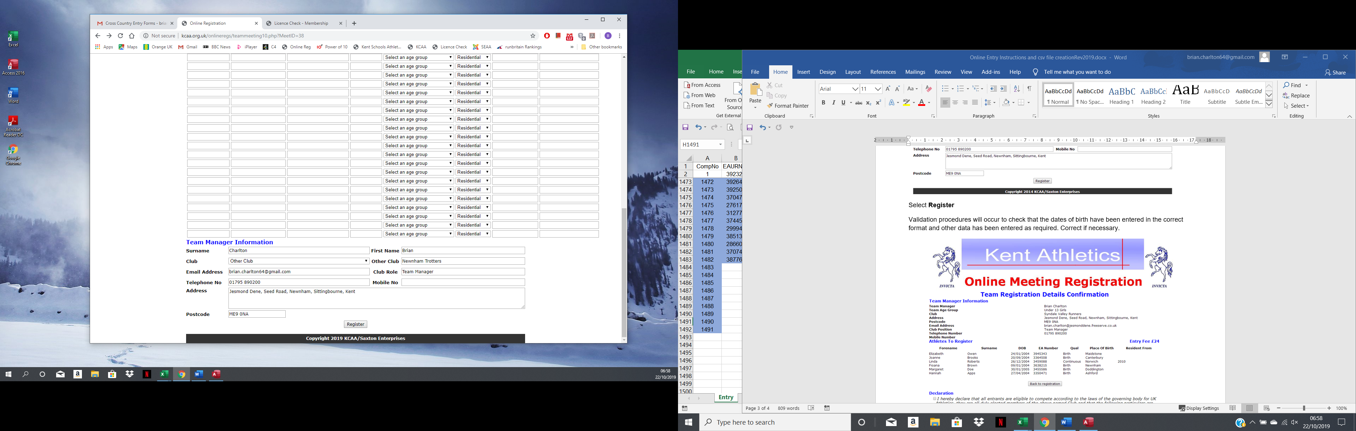

Select **Register**

Validation procedures will occur to check that the dates of birth have been entered in the correct format and other data has been entered as required. Correct if necessary.

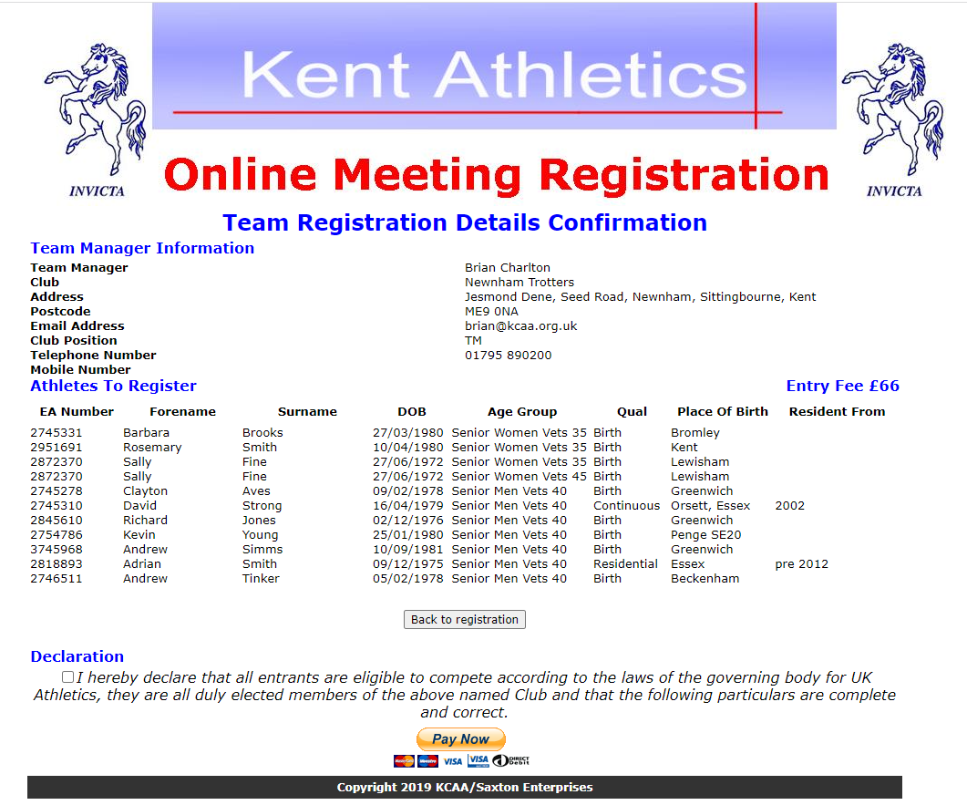

Complete the declaration and make payment.

Repeat the same entry process for additional entries or separate age groups if being entered that way.

Good Luck. If you have problems send me an email.

Brian